Name: ________________________________________________ Date: _________________________________
FQ #7: Max/Min and Inc/Dec

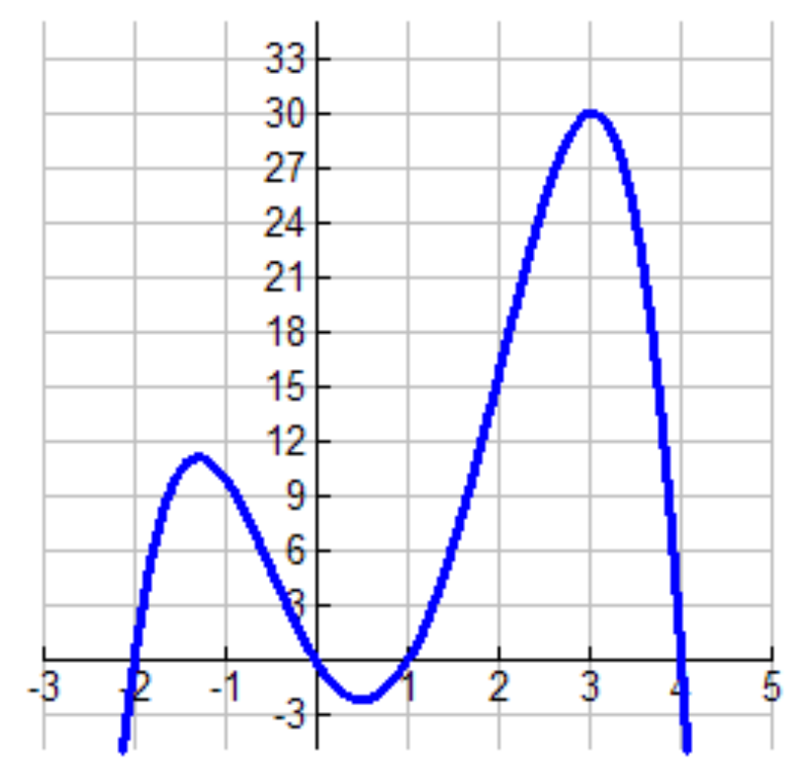 | 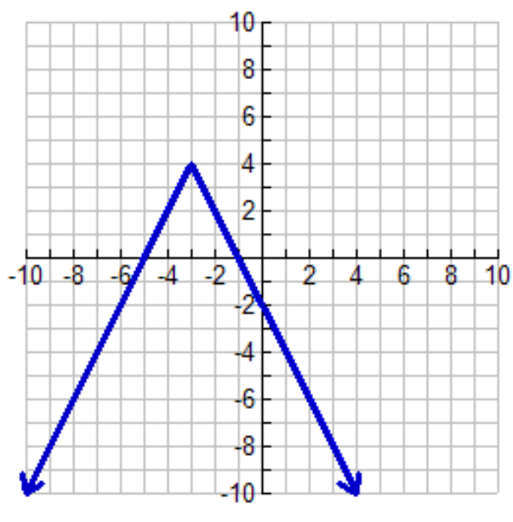
Function:  Domain:  Range:  x-intercept:  y-intercept:  Positive Interval:  Negative Interval:  Maxima:  Minima:  Interval Increasing:  Interval Decreasing: | Function:  Domain:  Range:  x-intercept:  y-intercept:  Positive Interval:  Negative Interval:  Maxima:  Minima:  Interval Increasing:  Interval Decreasing:

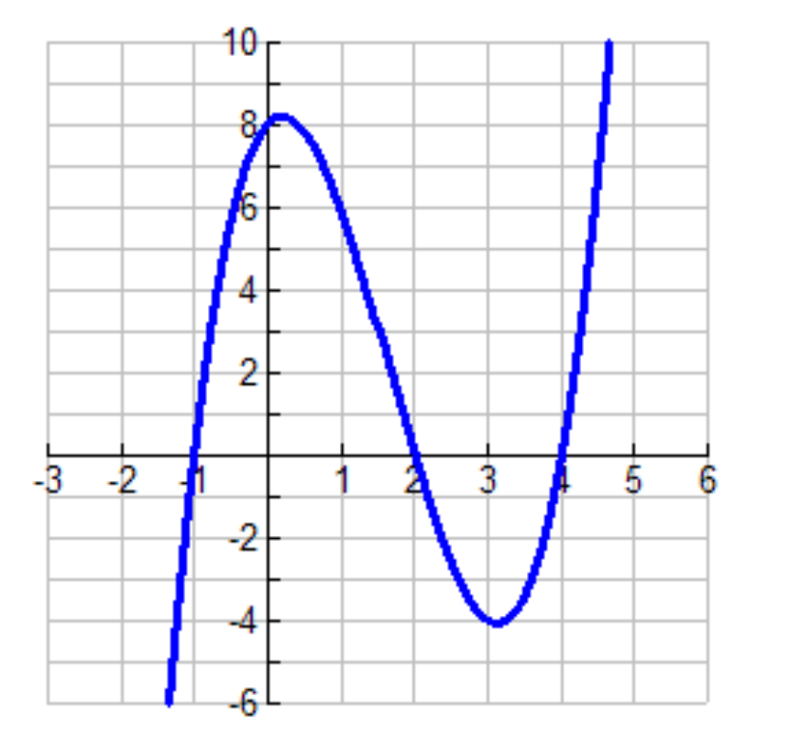 | 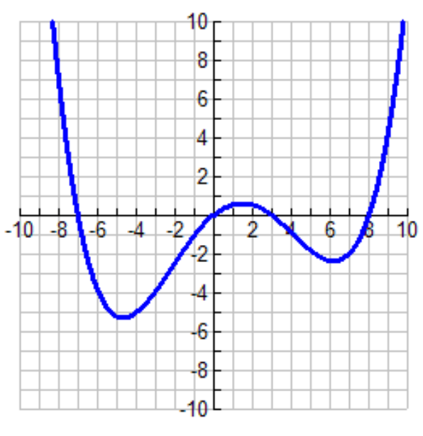
Function:  Domain:  Range:  x-intercept:  y-intercept:  Positive Interval:  Negative Interval:  Maxima:  Minima:  Interval Increasing:  Interval Decreasing: | Function:  Domain:  Range:  x-intercept:  y-intercept:  Positive Interval:  Negative Interval:  Maxima:  Minima:  Interval Increasing:  Interval Decreasing:
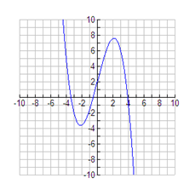
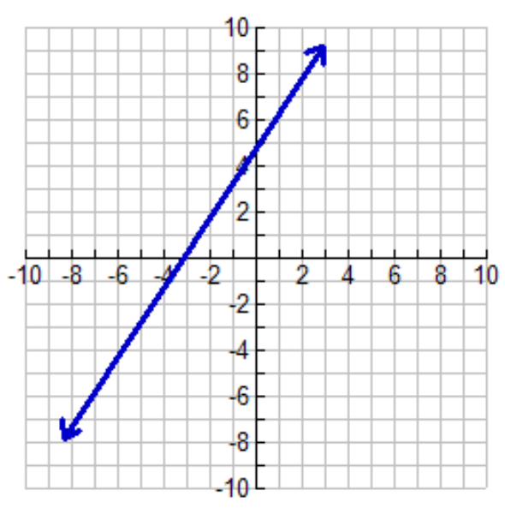

Function:  Domain:  Range:  x-intercept:  y-intercept:  Positive Interval:  Negative Interval:  Maxima:  Minima:  Interval Increasing:  Interval Decreasing: | Function:  Domain:  Range:  x-intercept:  y-intercept:  Positive Interval:  Negative Interval:  Maxima:  Minima:  Interval Increasing:  Interval Decreasing:

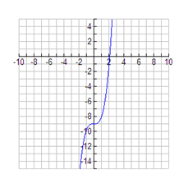 | 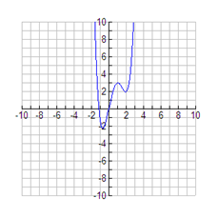
Function:  Domain:  Range:  x-intercept:  y-intercept:  Positive Interval:  Negative Interval:  Maxima:  Minima:  Interval Increasing:  Interval Decreasing: | Function:  Domain:  Range:  x-intercept:  y-intercept:  Positive Interval:  Negative Interval:  Maxima:  Minima:  Interval Increasing:  Interval Decreasing:

