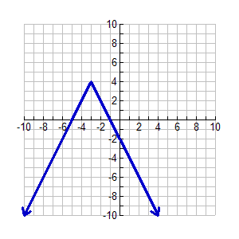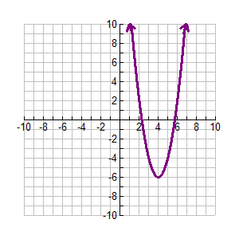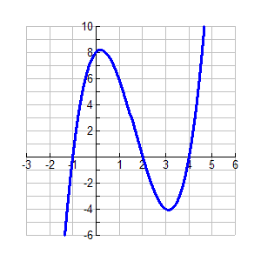

|  |  |  |  |
| --- | --- | --- | --- |
| Is it a function? Explain. |  |  |  |
| Domain |  |  |  |
| Range |  |  |  |
| Maxima |  |  |  |
| Minima |  |  |  |
| y-intercept(s) |  |  |  |
| x-intercept(s) |  |  |  |
| As x $→∞$, y $→ ___$ As x $→-∞$, y $→$___ |  |  |  |
| Increasing Intervals(s) |  |  |  |
| Decreasing interval(s) |  |  |  |
| Positive intervals |  |  |  |
| Negative intervals |  |  |  |

Find the x and y intercept for each:

a. y = 5/6 x – 10 b. 2x – 9y = 25 c. 3x + 5y = 45

**Let f(x) = 3x – 5, g(x) = x2 – 8x + 2, and h(x) = 12 – 7x. Simplify each expression.**

a. f(x) – g(x) b. g(x) – h(x) c. 2f(x) + g(x) d g(x) + 3h(x)