Name: _________**KEY**________________ Date: ___________________

Honors 10 - Exponential Review (Exponent Properties and 8.1-8.2)

1. **Write an exponential equation for each situation. Then evaluate for the given situation**
   1. A computer valued at $6500 depreciates at the rate of 10.4% each year. Write a function that models the situation; then evaluate the value of the computer after 3 years.

**y = 6500(.896)x x = # years y = value of computer**

**$4675.60**

* 1. The bird population was 3,265,321 in 1992 and increase at an annual rate of 2%. Write an equation to model the situation and estimate number of birds after 2 years.

**y = 3,265,321(1.02)x x = # years since 1992 y = number of birds**

**3,397,239 birds**

* 1. The NCAA holds an annual basketball tournament (March Madness). The top 64 teams are invited to play each March. When a team loses, it is out of the tournament. Write an equation to model the situation. How many teams are left after 4 rounds?

**y = 64(.5)x x = # rounds y = #teams remaining**

**4 teams**

* 1. Using the fact that technetium-99m has a half-life of 6 hours, write an equation and find the amount of technetium-99m that remains from a 90mg supply after 25 hours.

**y = 90(0.5)x/6 x = # hours y = amount of technetium-99**

**5.011 mg**

* 1. Your Grandma gave you $500 for you birthday. You decide to invest the money in an account that is compound continuously at a rate of 4.5%. Write an equation to model this situation. How much will you have in the bank after 6 years?

**y = 500(e).045t x = # years y = amount of money**

**$654.98**

* 1. Jacob buys a baseball card for $50 and it increases 4% each year in value. How much is the card worth after 30 years?

**y = 50(1.04)x x = # years y = value of baseball card**

**$162.17**

* 1. The half-life of a certain radioactive material is 70 days. An initial amount of the material has a mass of 702 kg. Write an exponential function that models the decay of this material. Find how much radioactive material remains after 10 days. Round your answer to the nearest thousandth.

**y = 702(0.5)x/70 x = # days y = amount of radioactive material**

**635.82 kg**

* 1. A sample of 250 bacteria for an experiment doubles every half hour. How much bacteria does the sample contain after 4 hours?

**y = 250(2)2x x = # hours y = number of bacteria**

**64,000 bacteria**

* 1. Jagerium has a half-life of 56 years. If you start out with 10mg, how much will you have left after: i.) 10 years? ii.) 1000 years? **y=10(0.5)x/56  x = # of years y = mg of Jagerium**

**8.84 mg .000042 mg**

1. **Write an exponential function that goes through the following points**

a.) (2, 10) and (-1, 4.5) b.) (-1, 12.25) and (1, 4)

**y = 6(4/3)x y = 7(0.571)x**

1. **Find the annual percent of increase or decrease for each equation**

a.) y = 2(5)x b.) y = .41(0.87)x c.) y = 1.1x d.) y = 0.3x

**400% increase 13% decrease 10% decrease 70% decrease**

1. **Find the growth or decay factor for each annual rate of change**

a.) 720% increase b.) 5% decrease c.) 2% d.) – 93%

**b =** **8.2 b =** **0.95 b =**  **1.02 b =**  **.07**

1. **Graph each exponential function, identify the transformations and answer all function questions.**

a.) y = 3x b.) y = ¾x – 1 c.) y = ½ (2/3)x – 9 d.) y= -80(1/2)x + 1 –4

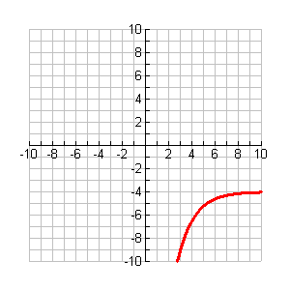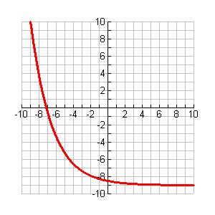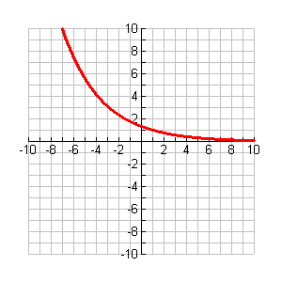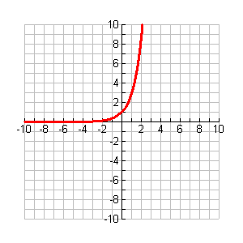

|  |  |  |  |  |
| --- | --- | --- | --- | --- |
|  | a. | b. | c. | d. |
| Function | **Yes** | **Yes** | **Yes** | **Yes** |
| Domain | $$R$$ | $$R$$ | $$R$$ | $$R$$ |
| Range | **(0,∞)** | **(0,∞)** | **(-9,∞)** | **(-∞, -4)** |
| Increasing | **(-∞,∞)** | **Never** | **Never** | **(-∞,∞)** |
| Decreasing | **Never** | **(-∞,∞)** | **(-∞,∞)** | **Never** |
| Positive | **(-∞,∞)** | **(-∞,∞)** | **(-∞,-7.13)** | **Never** |
| Negative | **Never** | **Never** | **(-7.13, ∞)** | **(-∞,∞)** |
| Critical Points | **None** | **None** | **None** | **None** |
| End Behavior | **As x 🡪∞, y🡪∞**  **As x 🡪-∞, y 🡪0** | **As x 🡪∞, y🡪0**  **As x 🡪-∞, y 🡪∞** | **As x 🡪∞, y🡪-9**  **As x 🡪-∞, y 🡪∞** | **As x 🡪∞, y🡪-4**  **As x 🡪-∞, y 🡪-∞** |
| x-intercept | **None** | **None** | **(-7.13, 0)** | **None** |
| y-intercept | **(0,1)** | **(0,4/3)** | **(0,-8.5)** | **(0, -44)** |
| Asymptotes | **y = 0** | **y = 0** | **y = -9** | **y = -4** |
| Transformations | **None** | **Graph y = (¾) x is translated right 1** | **Graph y =½ (2/3)x is translated down 9** | **Graph y = 80(½)x is reflected over the x-axis and translate left 1 and down 4** |
| inverse | **Yes** | **Yes** | **Yes** | **yes** |

1. **Simplify each expression using only positive exponents.**

a.) (6x2y) (3xy2) b. (-5a0b-5c-2)-3(2a-6b5) c. –(4x)-5(x4y-6z4)-3

**18x3y3**

d.  e.   f. 



g. (-⅔a5b3)-8 h.  i. 

**  **

1. **Write an equation to model the scenario and answer the questions.** 
   1. Suppose you invest $25,000 in an account earning 2.5% interest. How much will you have after 20 years, if the interest is compounded:
      1. Annually **$40,965.41 A = 25000(1 + .025/1)1*20**
      2. Quarterly **$41,153.95 A=25000(1+.025/4)4*20**
      3. Monthly **$41,196.60 A=25000(1+.025/12)12*20**
      4. Daily **$41,217.33 A=25000(1+.025/365)365*20**
      5. Continuously **$41,218.03 A=25000e.025*20**
   2. Suppose your parents wanted to have saved $115,000 for your college fund by the time you graduated high school. How much would they have had to invest 17 years ago in an account with a continuous interest rate of 7.2%?

**115,000 = Pe.072*17 $33,815.93**

* 1. Suppose they had chosen an account that was compounded annually instead. How much would they have needed to invest?

**115,000 = P(1+.072/1)1*17 $35,268.46**